

**SIMATS SCHOOL OF ENGINEERING**

**SAVEETHA INSTITUTE OF MEDICAL AND TECHNICAL SCIENCES**

**CHENNAI-602105**

**Online Bus Ticket Booking**

**A CAPSTONE PROJECT REPORT**

*Submitted in the partial fulfillment for the award of the degree of*

**BACHELOR OF ENGINEERING**

**IN**

**COMPUTER SCIENCE**

**Submitted by**

**K Pranav Kumar Reddy (192211441)**

**K Kushu Vardhan Reddy (192211776)**

**K Madhusudhan (192210035)**

**Under the Supervision of**

**Dr A Moorthy**

**JULY 2024**

**DECLARATION**

We, K Pranav Kumar Reddy**, K Kushu Vardhan Reddy, K Madhusudhan** students of **Bachelor of Engineering**, Department of Computer Science and Engineering, Saveetha Institute of Medical and Technical Sciences, Saveetha University, Chennai, hereby declare that the work presented in this Capstone Project Work entitled **Online bus ticket booking** is the outcome of our own bonafide work and is correct to the best of our knowledge and this work has been undertaken taking care of Internet Programming.

(Pranav K 192211441)

(Madhusudhan K 192210035)

(Kushu Vardhan K 192211776)

Date: 29-07-2024

Place: Chennai

**CERTIFICATE**

This is to certify that the project entitled **“Online bus ticket booking”** submitted by K Pranav Kumar Reddy**, K Kushu Vardhan Reddy, K Madhusudhan** has been carried out under my supervision. The project has been submitted as per the requirements in the current semester of B. Tech Computer Science.

Teacher-in-charge

**Dr A Moorthy**

**Table of Contents**

|  |  |
| --- | --- |
| **S.NO** | **TOPICS** |
| 1 | **Abstract** |
| 2 | **Introduction** |
| 3 | **Project Description**  About your project |
| 4 | **Problem Description**  Program to build a simple Software for < > |
| 5 | **Tool Description**  User interface  Features |
| 6 | **Operations**  Store the First name of the student.  Store the Last name of the student.  Store the unique Roll number for every student.  Store the CGPA of every student.  Store the courses registered by the student. |
| 7 | **Approach / Module Description / Functionalities**  The idea is to form an individual functions for every operation. All the functions are unified together to form software. |
| 8 | **Implementation**  Coding |
| 9 | **Output**  Output with Screenshots |
| 10 | **Conclusion**  Future Enhancement  **References** |

**Abstract:** This project entails the design and implementation of a simple software system for online bus ticket booking. The system aims to streamline the booking process, making it efficient and user-friendly. Key functionalities include user registration, ticket booking, payment processing, and ticket cancellation. The project uses a modular approach to ensure scalability and ease of maintenance.

**Introduction**: The online bus ticket booking system is designed to provide a convenient platform for users to book bus tickets. This system addresses the inefficiencies of traditional ticket booking methods, offering a seamless and hassle-free experience. The software leverages modern web technologies to ensure reliability, security, and scalability.

**Project Description**: This project involves developing an online platform where users can search for buses, view seat availability, book tickets, and make payments. It also includes functionalities for user registration, login, and management of booking history.

**About Your Project**: The primary goal of this project is to create a software solution that simplifies the process of booking bus tickets. The system provides an intuitive interface, making it easy for users to navigate and complete their bookings with minimal effort.

**Problem Description**: Traditional bus ticket booking methods are often cumbersome, time-consuming, and prone to errors. This project aims to address these issues by developing a digital platform that automates and streamlines the booking process, reducing the time and effort required to book tickets.

Program to Build a Simple Software for Online Bus Ticket Booking: The program will be developed using a combination of front-end and back-end technologies. It will include features such as user registration, bus schedule management, seat selection, payment processing, and ticket generation.

**Tool Description**: The following tools and technologies will be used in the development of the software:

* Frontend: HTML, CSS, JavaScript, React.js
* Backend: Node.js, Express.js
* Database: MongoDB
* Payment Gateway: PayPal API or Stripe API
* Version Control: Git, GitHub

**User Interface**: The user interface will be designed to be intuitive and user-friendly. It will consist of the following main sections:

* Home Page: Search for buses, view schedules, and promotional offers.
* Registration/Login Page: User registration and login functionality.
* Booking Page: Select bus, choose seats, and proceed to payment.
* Payment Page: Enter payment details and confirm booking.
* User Dashboard: View booking history and manage account details.

**Features**:

* User registration and login
* Search for available buses
* View bus schedules and seat availability
* Book and cancel tickets
* Make payments securely
* View and manage booking history

**Operations**: The software will perform the following operations:

1. Store the first name of the user.
2. Store the last name of the user.
3. Store a unique user ID for every user.
4. Store the contact information of the user.
5. Store the booked ticket details, including the bus ID, seat number, and travel date.

**Approach / Module Description / Functionalities**: The idea is to form individual functions for every operation. All the functions are unified together to form the software.

**Implementation**: The implementation involves the following steps:

1. Setup Development Environment: Install necessary tools and set up the project structure.
2. Develop Frontend: Create the user interface using HTML, CSS, and JavaScript.
3. Develop Backend: Implement server-side logic using Node.js and Express.js.
4. Database Integration: Connect the application to MongoDB and implement data storage functionalities.
5. Payment Gateway Integration: Integrate PayPal or Stripe for payment processing.
6. Testing: Conduct thorough testing to ensure all functionalities work as expected.
7. Deployment: Deploy the application on a web server for public access.

**Coding**

**Login Page**

<!DOCTYPE html>

<html lang="en">

<head>

<meta charset="UTF-8">

<meta name="viewport" content="width=device-width, initial-scale=1.0">

<title>Login</title>

<style>

body {

font-family: Arial, sans-serif;

display: flex;

justify-content: flex-end;

align-items: center;

height: 100vh;

margin: 0;

background: url('https://tse4.mm.bing.net/th?id=OIP.wEWh3QBQhfboBCQ50ruQzgHaE8&pid=Api&P=0&h=180') no-repeat center center fixed;

background-size: cover;

}

.container {

background-color: rgba(255, 255, 255, 0.9);

padding: 40px;

box-shadow: 0 0 10px rgba(0, 0, 0, 0.1);

border-radius: 10px;

width: 500px;

margin-right: 50px;

}

.container h2 {

margin-top: 0;

font-size: 32px;

}

.form-group {

margin-bottom: 20px;

}

.form-group label {

display: block;

margin-bottom: 10px;

font-size: 18px;

}

.form-group input {

width: 100%;

padding: 15px;

box-sizing: border-box;

font-size: 18px;

}

.form-group button {

width: 100%;

padding: 15px;

background-color: #0000ff ;

color: white;

border: none;

border-radius: 5px;

cursor: pointer;

font-size: 18px;

}

.form-group button:hover {

background-color: #218838;

}

.form-group a {

display: block;

text-align: center;

margin-top: 15px;

color: #007bff;

font-size: 16px;

}

</style>

</head>

<body>

<div class="container">

<h2>Login</h2>

<form action="dblogin.php" method="POST">

<div class="form-group">

<label for="username">Username:</label>

<input type="text" id="username" name="username" required>

</div>

<div class="form-group">

<label for="password">Password:</label>

<input type="password" id="password" name="password" required>

</div>

<div class="form-group">

<button type="submit">Login</button>

</div>

<div class="form-group">

<a href="registrationpage.php">Create Account</a>

</div>

</form>

</div>

</body>

</html>

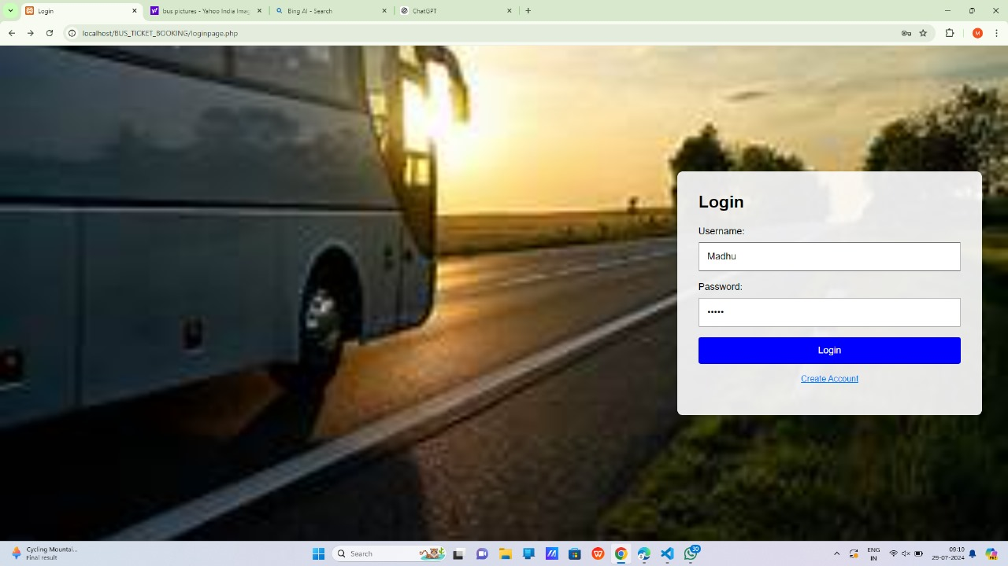

**Register Page**

<!DOCTYPE html>

<html lang="en">

<head>

<meta charset="UTF-8">

<meta name="viewport" content="width=device-width, initial-scale=1.0">

<title>Register</title>

<style>

body {

font-family: Arial, sans-serif;

display: flex;

justify-content: center; /* Aligns the content to the center */

align-items: center;

height: 100vh;

margin: 0;

background: url('http://3.bp.blogspot.com/_vbSrwOg2sZw/TSMKDqDL_4I/AAAAAAAAFIQ/8wJlN_1I5e4/s1600/Volvo-Bus-intro.jpg') no-repeat center center fixed;

background-size: cover;

}

.container {

background-color: rgba(255, 255, 255, 0.9);

padding: 20px;

box-shadow: 0 0 10px rgba(0, 0, 0, 0.1);

border-radius: 5px;

width: 300px;

margin-left: -150px; /* Adjusts the margin to move the container towards the left */

}

.container h2 {

margin-top: 0;

}

.form-group {

margin-bottom: 15px;

}

.form-group label {

display: block;

margin-bottom: 5px;

}

.form-group input,

.form-group select {

width: 100%;

padding: 8px;

box-sizing: border-box;

}

.form-group button {

width: 100%;

padding: 10px;

background-color: #007bff;

color: white;

border: none;

border-radius: 5px;

cursor: pointer;

}

.form-group button:hover {

background-color: #0056b3;

}

</style>

</head>

<body>

<div class="container">

<h2>Register</h2>

<form action="dbregister.php" method="post">

<div class="form-group">

<label for="username">Username:</label>

<input type="text" id="username" name="username" required>

</div>

<div class="form-group">

<label for="email">Email:</label>

<input type="email" id="email" name="email" required>

</div>

<div class="form-group">

<label for="password">Password:</label>

<input type="password" id="password" name="password" required>

</div>

<div class="form-group">

<label for="confirm-password">Confirm Password:</label>

<input type="password" id="confirm-password" name="confirm_password" required>

</div>

<div class="form-group">

<label for="phone">Phone Number:</label>

<input type="tel" id="phone" name="phone" required>

</div>

<div class="form-group">

<label for="gender">Gender:</label>

<select id="gender" name="gender" required>

<option value="">Select Gender</option>

<option value="male">Male</option>

<option value="female">Female</option>

<option value="other">Other</option>

</select>

</div>

<div class="form-group">

<button type="submit">Register</button>

</div>

</form>

</div>

</body>

</html>

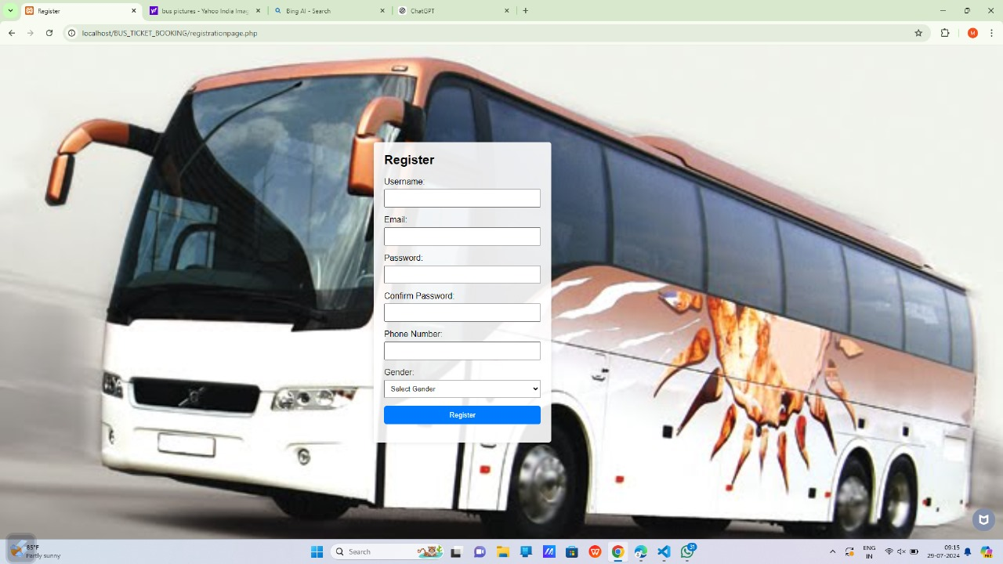

**Home Page**

<!DOCTYPE html>

<html lang="en">

<head>

<meta charset="UTF-8">

<meta name="viewport" content="width=device-width, initial-scale=1.0">

<title>Online Bus Ticket Booking System</title>

<style>

body {

font-family: Arial, sans-serif;

margin: 0;

padding: 0;

background: url('https://yaatrisewa.com/yaatrisewa/slider/images/site/online-bus-ticket-booking-yaatri-sewa-travels-01.jpg') no-repeat center center fixed;

background-size: cover;

display: flex;

flex-direction: column;

min-height: 100vh;

}

.header {

background-color: #28a745;

color: white;

padding: 20px;

text-align: center;

}

.nav {

display: flex;

justify-content: center;

background-color: #333;

}

.nav a {

color: white;

padding: 14px 20px;

text-decoration: none;

text-align: center;

}

.nav a:hover {

background-color: #ddd;

color: black;

}

.main {

flex: 1;

padding: 20px;

text-align: center;

}

.footer {

background-color: #333;

color: white;

text-align: center;

padding: 10px;

position: relative;

width: 100%;

}

</style>

</head>

<body>

<div class="header">

<h1>Online Bus Ticket Booking System</h1>

</div>

<div class="nav">

<a href="loginpage.php">Login</a>

<a href="registrationpage.php">Register</a>

<a href="book-ticket.php">Book Ticket</a>

<a href="bus-schedule.php">Bus Schedule</a>

<a href="generate-reports.php">Generate Reports</a>

</div>

<div class="main">

<h2>Welcome to the Online Bus Ticket Booking System</h2>

<p>Book your bus tickets online easily and conveniently. Use the navigation bar to log in, register, book tickets, view bus schedules, or generate reports.</p>

</div>

<div class="footer">

<p>&copy; 2024 Online Bus Ticket Booking System</p>

</div>

</body>

</html>

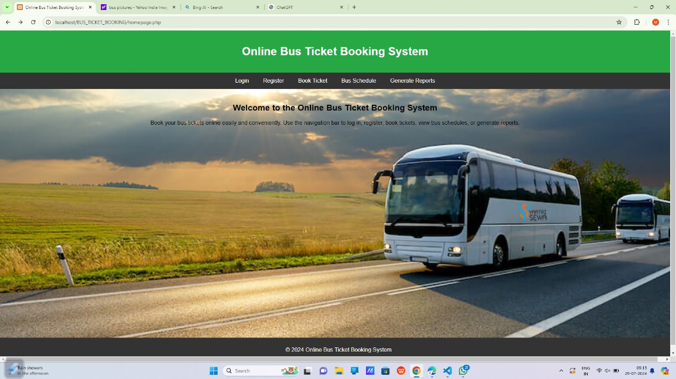

**Book Ticket**

<!DOCTYPE html>

<html lang="en">

<head>

<meta charset="UTF-8">

<meta name="viewport" content="width=device-width, initial-scale=1.0">

<title>Book Ticket</title>

<link rel="stylesheet" href="styles.css">

</head>

<body>

<style>

body {

font-family: Arial, sans-serif;

background: url('https://tse1.mm.bing.net/th?id=OIP.MNfKCJwqBZkQS5aXT6aKMAAAAA&pid=Api&P=0&h=180') no-repeat center center fixed;

background-size: cover;

margin: 0;

padding: 0;

display: flex;

justify-content: center;

align-items: center;

height: 100vh;

}

.container {

background-color: rgba(255, 255, 255, 0.9);

padding: 20px;

box-shadow: 0 0 10px rgba(0, 0, 0, 0.1);

border-radius: 5px;

width: 300px;

}

.container h2 {

margin-top: 0;

text-align: center;

}

.form-group {

margin-bottom: 15px;

}

.form-group label {

display: block;

margin-bottom: 5px;

}

.form-group input {

width: 100%;

padding: 8px;

box-sizing: border-box;

border: 1px solid #ccc;

border-radius: 5px;

}

.form-group button {

width: 100%;

padding: 10px;

background-color: #28a745;

color: white;

border: none;

border-radius: 5px;

cursor: pointer;

}

.form-group button:hover {

background-color: #218838;

}

</style>

<div class="container">

<h2>Book Ticket</h2>

<form action="book-ticket.php" method="post">

<div class="form-group">

<label for="origin">Origin:</label>

<input type="text" id="origin" name="origin" required>

</div>

<div class="form-group">

<label for="destination">Destination:</label>

<input type="text" id="destination" name="destination" required>

</div>

<div class="form-group">

<label for="date">Date:</label>

<input type="date" id="date" name="date" required>

</div>

<div class="form-group">

<button type="submit">Book Ticket</button>

</div>

</form>

</div>

</body>

</html>

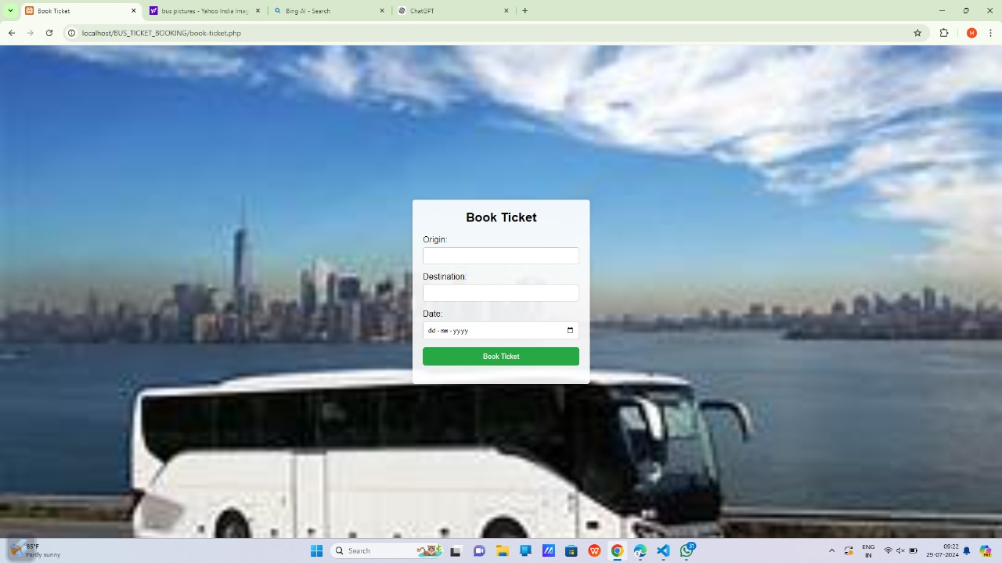

**Bus Schedule**

<!DOCTYPE html>

<html lang="en">

<head>

<meta charset="UTF-8">

<meta name="viewport" content="width=device-width, initial-scale=1.0">

<title>Bus Schedule</title>

<link rel="stylesheet" href="styles.css">

<style>

table {

width: 100%;

border-collapse: collapse;

margin-top: 20px;

}

th, td {

border: 1px solid #ccc;

padding: 10px;

text-align: left;

}

th {

background-color: #f4f4f4;

}

</style>

</head>

<body>

<div class="container">

<h2>Bus Schedule</h2>

<table>

<thead>

<tr>

<th>Bus Timing</th>

<th>Source</th>

<th>Destination</th>

<th>Stops</th>

<th>Arrival Time</th>

<th>Route</th>

</tr>

</thead>

<tbody>

<tr>

<td>08:00 AM</td>

<td>Kadapa</td>

<td>Tirupati</td>

<td>Razampeta, Railway Kodur</td>

<td>11:00 AM</td>

<td>Highway</td>

</tr>

<tr>

<td>09:30 AM</td>

<td>Kadapa</td>

<td>Proddatur</td>

<td>Mydukur, Chagalamarri</td>

<td>11:30 AM</td>

<td>From Chagalamarri highway to Proddatur</td>

</tr>

<tr>

<td>11:00 AM</td>

<td>Kadapa</td>

<td>Nandyala</td>

<td>Duvvur, Allagadda</td>

<td>1:00 PM</td>

<td>From Station Duvvur bypass to Allagadda</td>

</tr>

<tr>

<td>01:00 PM</td>

<td>Kadapa</td>

<td>Nellore</td>

<td>Badvel, Marripadu</td>

<td>06:00 PM</td>

<td>From Station Badvel bypass to Nellore</td>

</tr>

<tr>

<td>06:00 PM</td>

<td>Kadapa</td>

<td>Hyderabad</td>

<td>Nandyala, Kurnool</td>

<td>04:00 AM</td>

<td>From Station Kurnool bypass to Hyderabad</td>

</tr>

<!-- Add more rows as needed -->

</tbody>

</table>

</div>

</body>

</html>

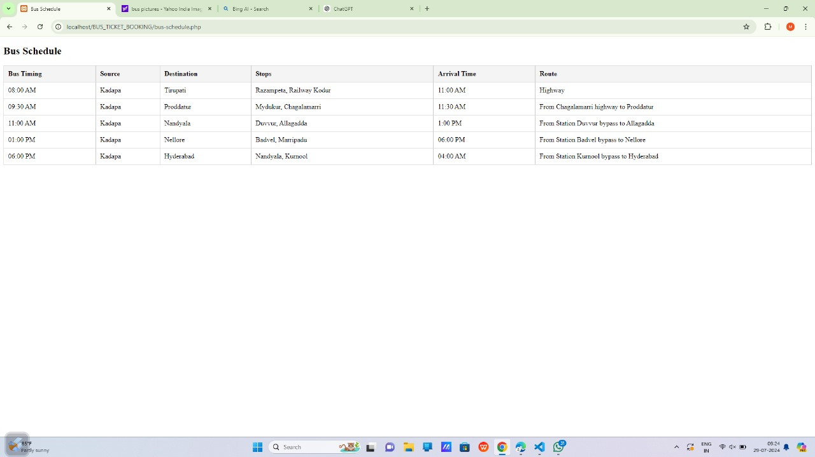

**Generate Reports**

<!DOCTYPE html>

<html lang="en">

<head>

<meta charset="UTF-8">

<meta name="viewport" content="width=device-width, initial-scale=1.0">

<title>Generate Reports</title>

<link rel="stylesheet" href="styles.css">

<style>

body {

font-family: Arial, sans-serif;

background: url('https://tse3.mm.bing.net/th?id=OIP.Ck6FMtiKfgoRjcTycPxNsQHaE8&pid=Api&P=0&h=180') no-repeat center center fixed;

background-size: cover;

margin: 0;

padding: 0;

height: 100vh;

display: flex;

justify-content: center;

align-items: center;

}

.container {

max-width: 800px;

margin: 50px auto;

background-color: rgba(255, 255, 255, 0.9);

padding: 40px;

box-shadow: 0 0 10px rgba(0, 0, 0, 0.1);

border-radius: 8px;

}

h2 {

text-align: center;

color: #333;

}

.form-group {

margin-bottom: 15px;

}

.form-group label {

display: block;

margin-bottom: 5px;

color: #333;

font-size: 18px;

}

.form-group select,

.form-group input[type="date"],

.form-group button {

width: 100%;

padding: 15px;

border: 1px solid #ccc;

border-radius: 4px;

font-size: 16px;

}

.form-group button {

background-color: #28a745;

color: #fff;

border: none;

cursor: pointer;

}

.form-group button:hover {

background-color: #218838;

}

</style>

</head>

<body>

<div class="container">

<h2>Generate Reports</h2>

<form action="generate-reports.php" method="post">

<div class="form-group">

<label for="report-type">Report Type:</label>

<select id="report-type" name="report_type" required>

<option value="">Select Report Type</option>

<option value="user_reports">User Reports</option>

<option value="booking_reports">Booking Reports</option>

<option value="comment_reports">Comment Reports</option>

</select>

</div>

<div class="form-group">

<label for="start-date">Start Date:</label>

<input type="date" id="start-date" name="start_date" required>

</div>

<div class="form-group">

<label for="end-date">End Date:</label>

<input type="date" id="end-date" name="end_date" required>

</div>

<div class="form-group">

<button type="submit">Generate Report</button>

</div>

</form>

</div>

</body>

</html>

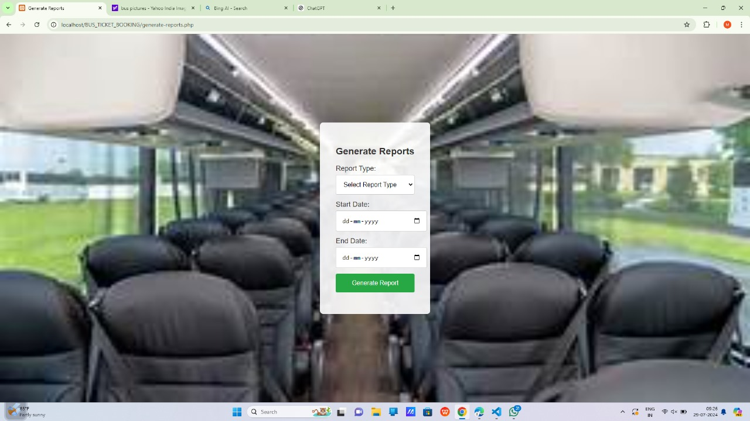

**Conclusion**: The online bus ticket booking system provides a modern and efficient solution for booking bus tickets. It simplifies the process, making it accessible and convenient for users. Future enhancements could include mobile app development, additional payment options, and integration with other transportation services.

**Future Enhancement:**

* Develop a mobile application for Android and iOS platforms.
* Integrate additional payment gateways.
* Implement advanced search and filtering options.
* Provide real-time bus tracking and notifications.
* Collaborate with other transportation services for a comprehensive travel solution.

**References:**

* Documentation and tutorials on HTML, CSS, JavaScript, React.js, Node.js, Express.js, and MongoDB.
* Official documentation for PayPal and Stripe APIs.
* Online resources and articles on best practices for web development and user experience design.